

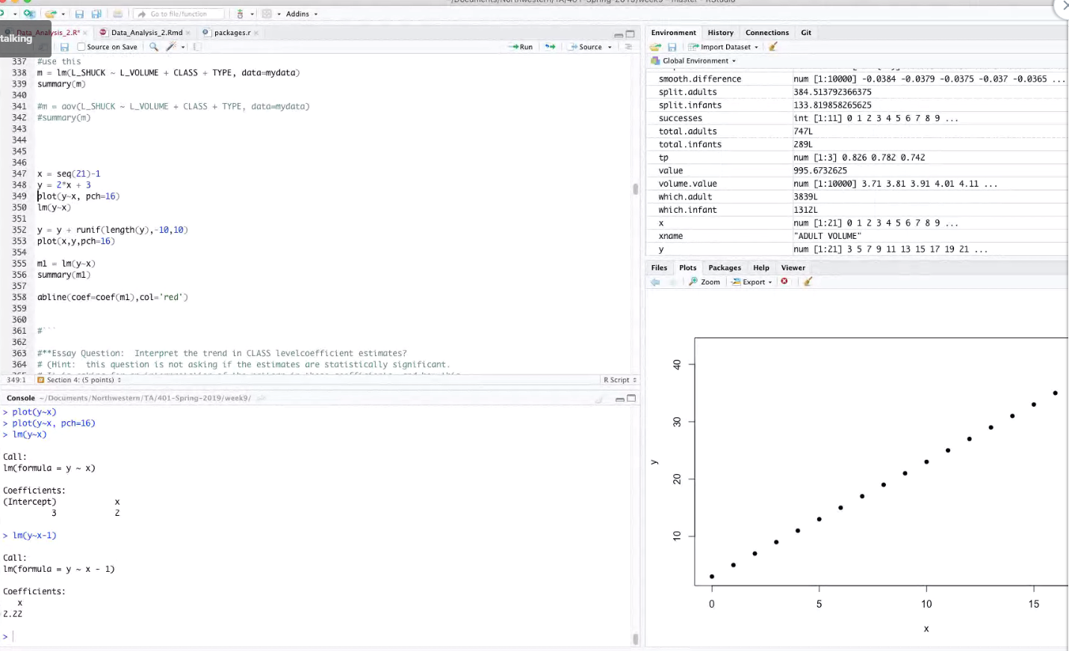

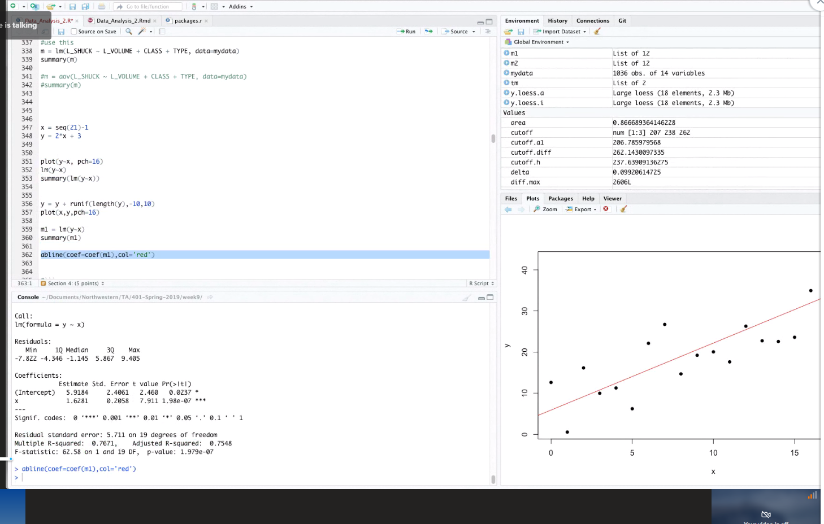

in the results of the aov() function, is Pr(>F) the same as a p-value? Probability of >F critical value?

an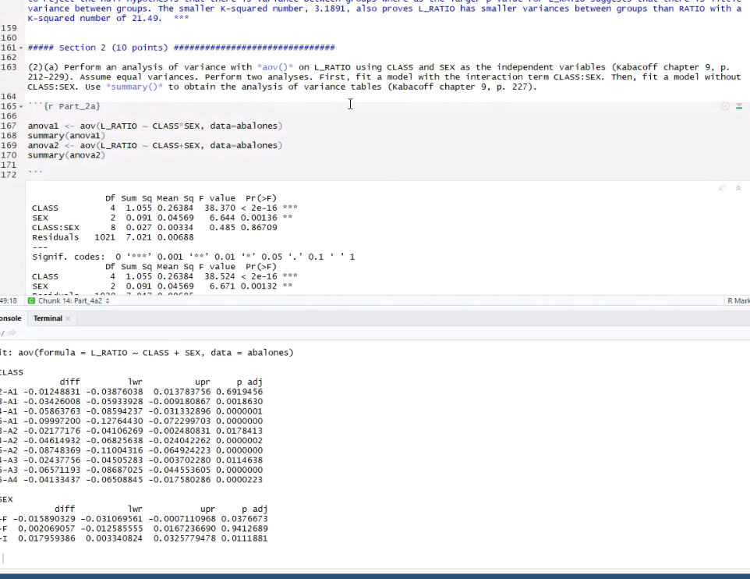

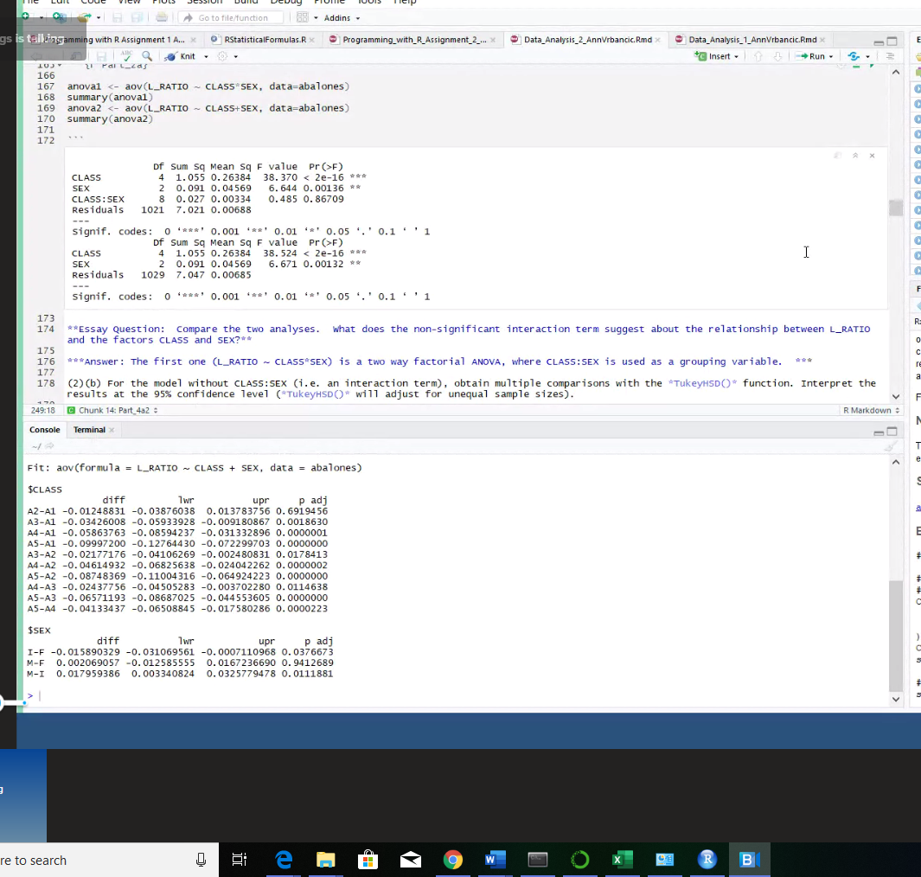

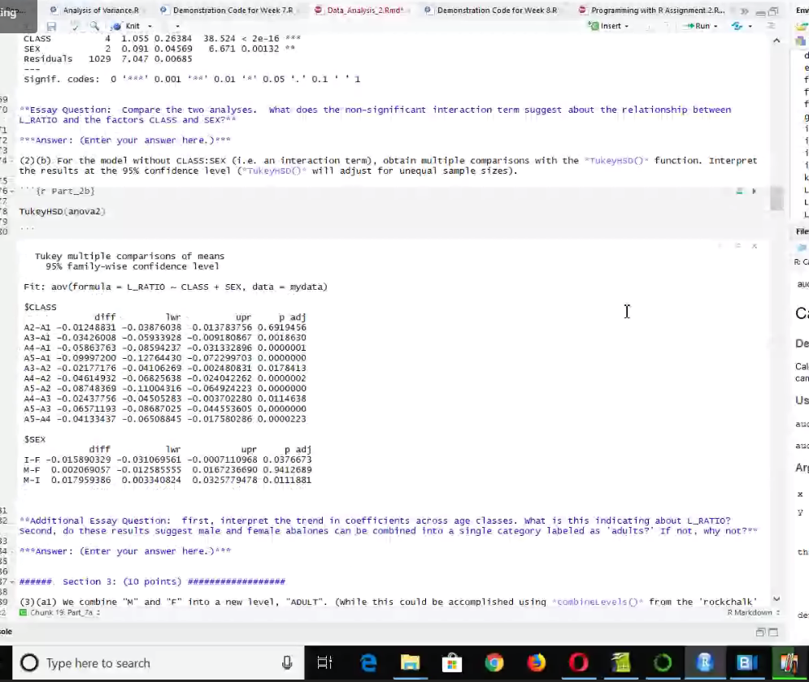

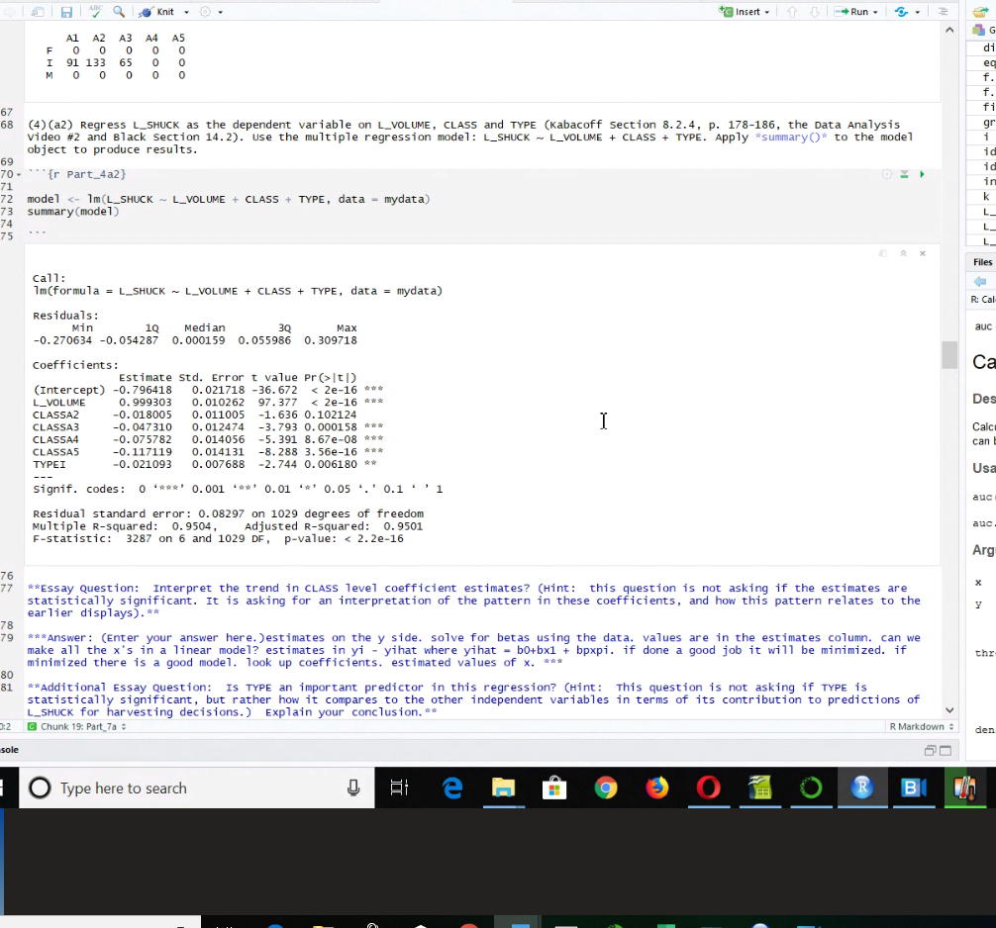

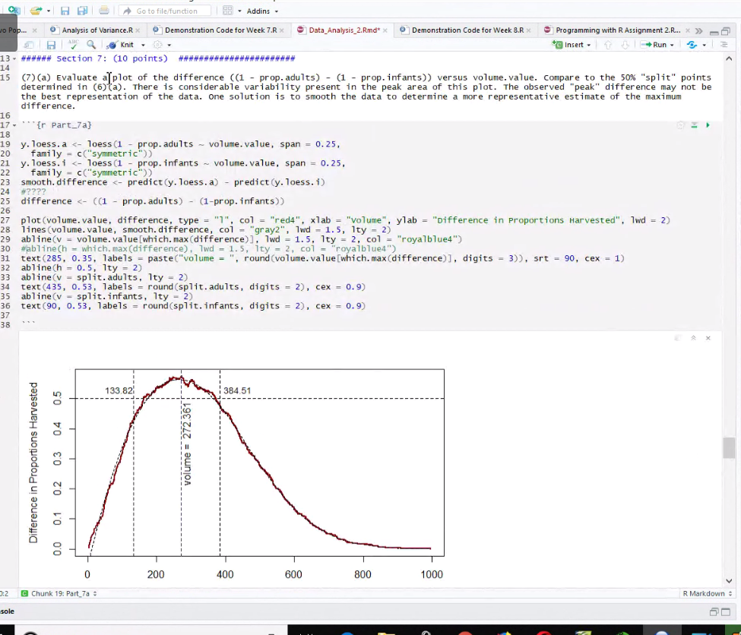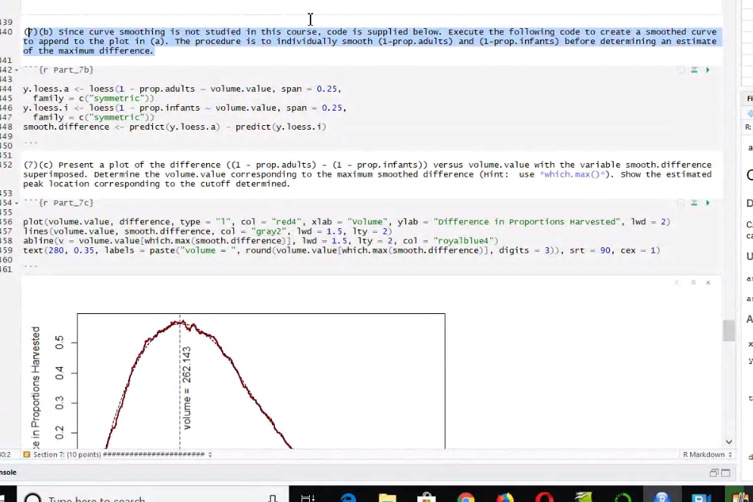

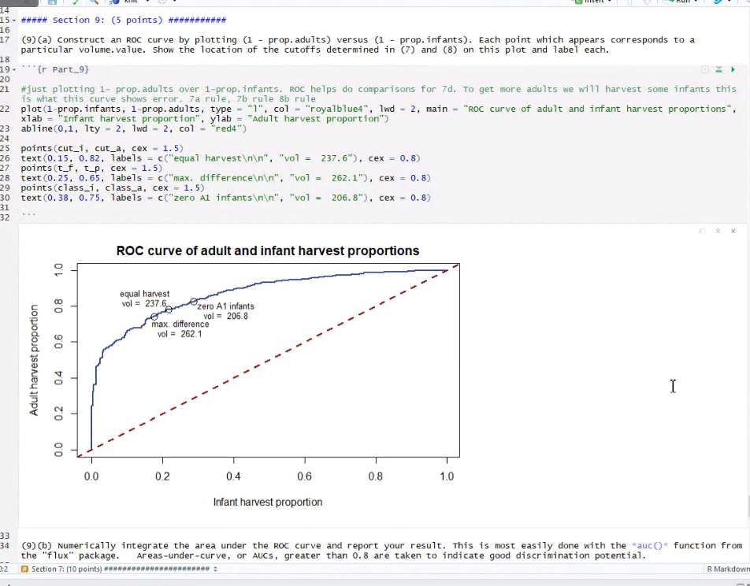

False positive and false negative.

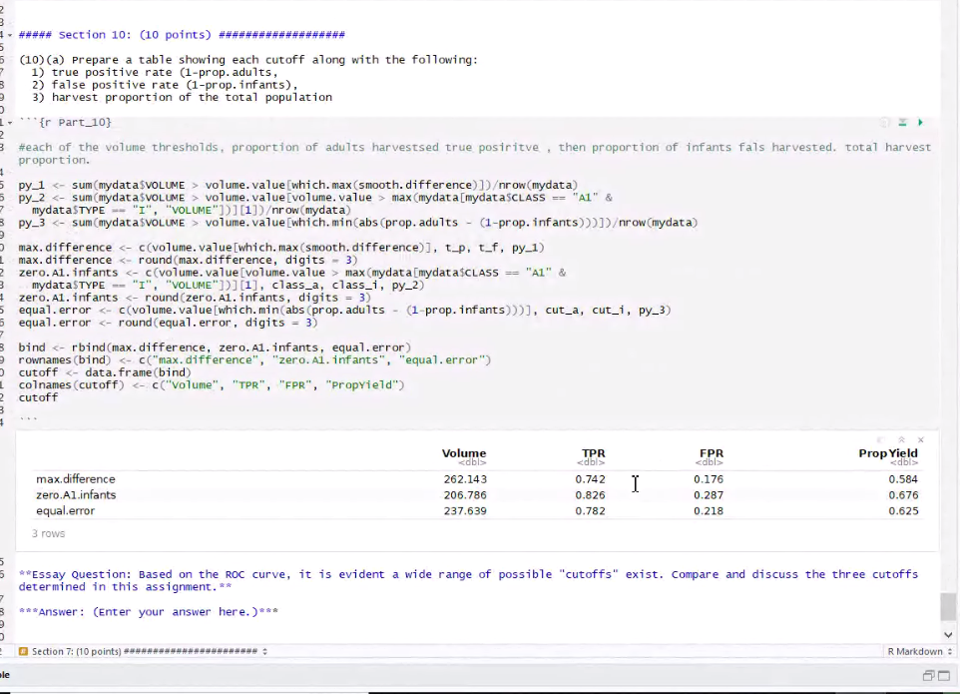

For those points (and the table in 10), I used my results from the following problems:  
  
7c and 7d  
max.difference <- volume.value[which.max(smooth.difference)]   
max.difference.adults <- (1 - prop.adults)[which.max(smooth.difference)]  
...etc.  
  
8a  
zero.A1 <- volume.value[volume.value > max(mydata[mydata$CLASS == "A1" &  
mydata$TYPE == "I", "VOLUME"])][1]  
zero.A1.adults <- sum(mydata$VOLUME > cutoff8a & mydata$TYPE == "ADULT")/total.adults  
...etc.  
  
8b   
equal.error <- volume.value[which.min(abs(prop.adults - (1-prop.infants)))]  
...Proportions calculated in the same way as 8a, but using equal.error  
  
Does that help? I'm not sure if that's what you're trying to figure out, but the proportions corresponding to each cutoff (such as max.difference.adults and zero.A1.adults, etc.) are what I used to find the points on the chart in 9.